6 Main Religions
Name of Religion | Christianity | Islam | Hinduism | Buddhism | Sikkhism | Judaism
Holy Book | Bible | Qu’ran | Vedas | Tripitaka | Guru Granth Sahib | Torah
Place of worship | Church | Mosque | Mandir / Temple | Temple | Gurdwara | Synagogue
Symbol | 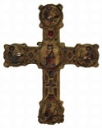  Cross/  fish  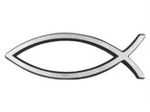 | Star and Crescent | Omkah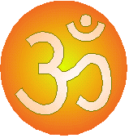 | 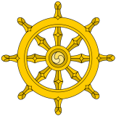  Wheel of Dharma | Khanda  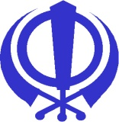 | Star of David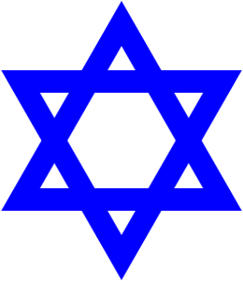
Important Person / Founder | Jesus | Mohammed | None | Buddha | Guru Nanek | Abraham
Any other information: (e.g important festivals, rituals etc.) | Christmas  Easter | Eid  Ramadan  Muslim  Allah | Diwali | Dalia Lama  Wesak  Dharma Day | Diwali | Hannukah  Passover

